CS 255 System Design Document Template

This template lays out all the different sections that you need to complete for Project Two. Each section has guidance to prompt your thinking. You will need to continually reference the interview transcript as you work to make sure that you are addressing your client’s needs. There is no required length for the final document. Instead the goal is to complete each section based on what your client’s needs are. Remove this note when you are finished, and replace all bracketed text with the relevant information.

UML Diagrams

UML Use Case Diagram
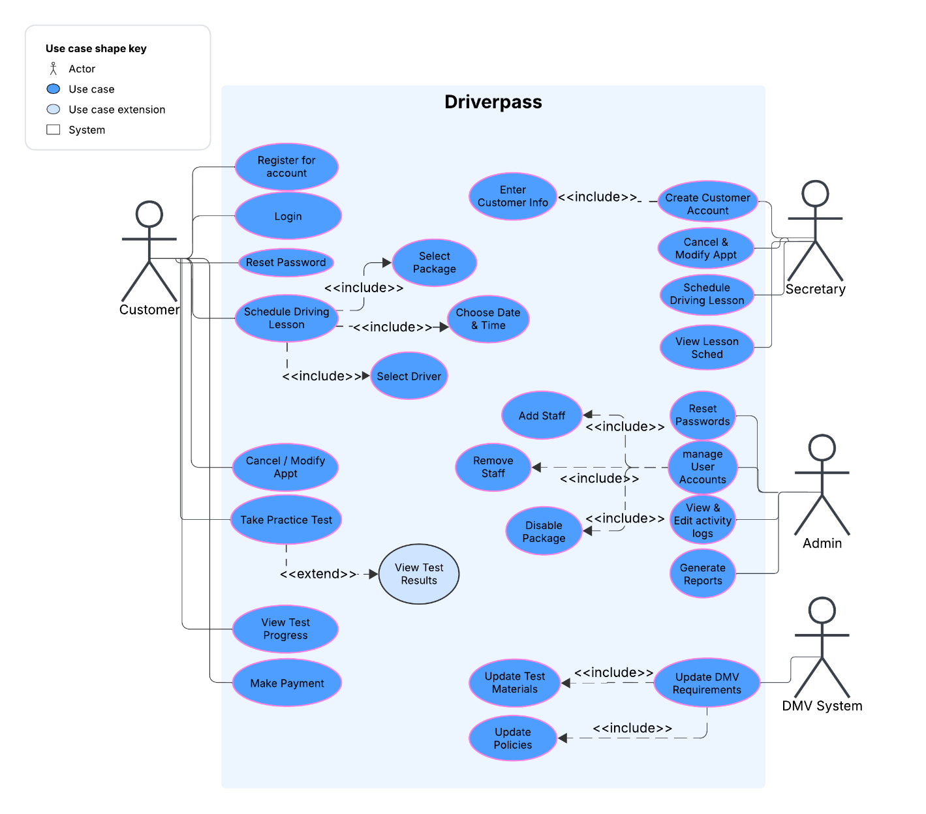

UML Activity Diagrams

Activity diagram 1: Schedule a driving lesson
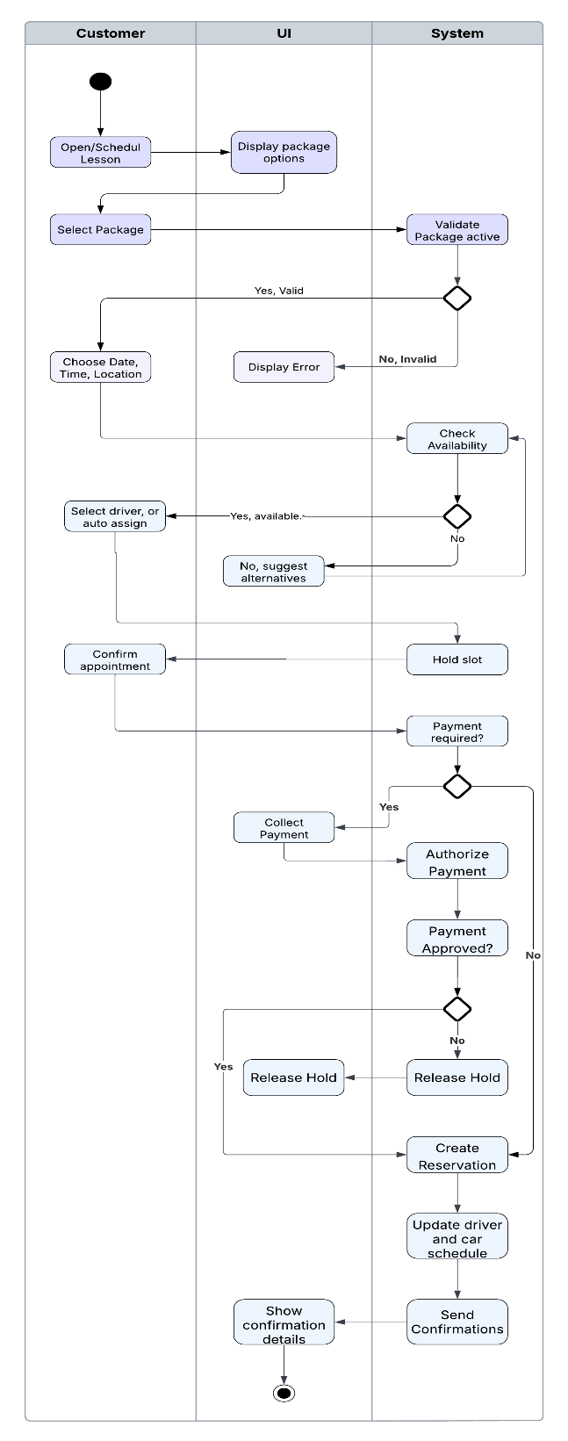

Activity diagram 2
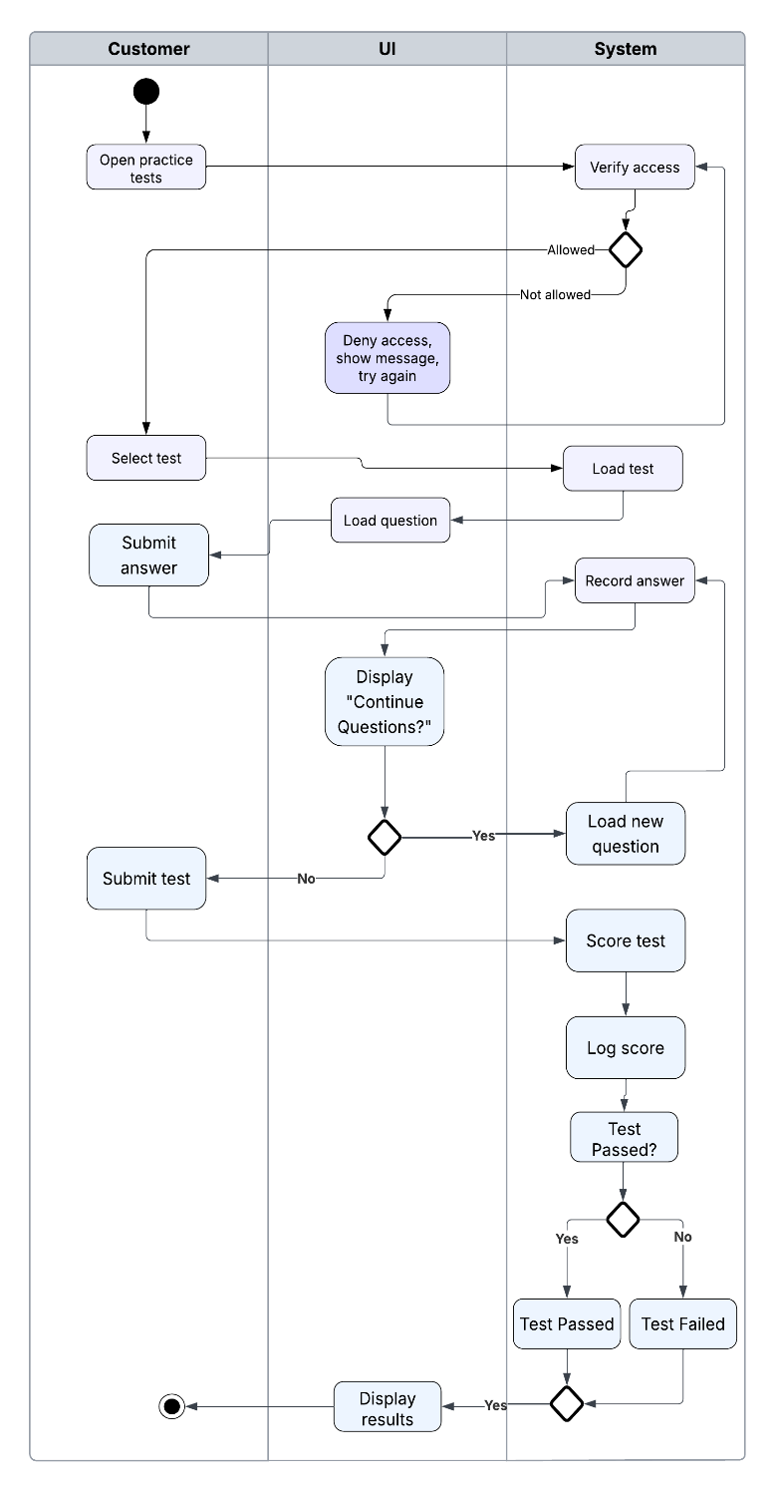

UML Sequence Diagram: Schedule a driving lesson
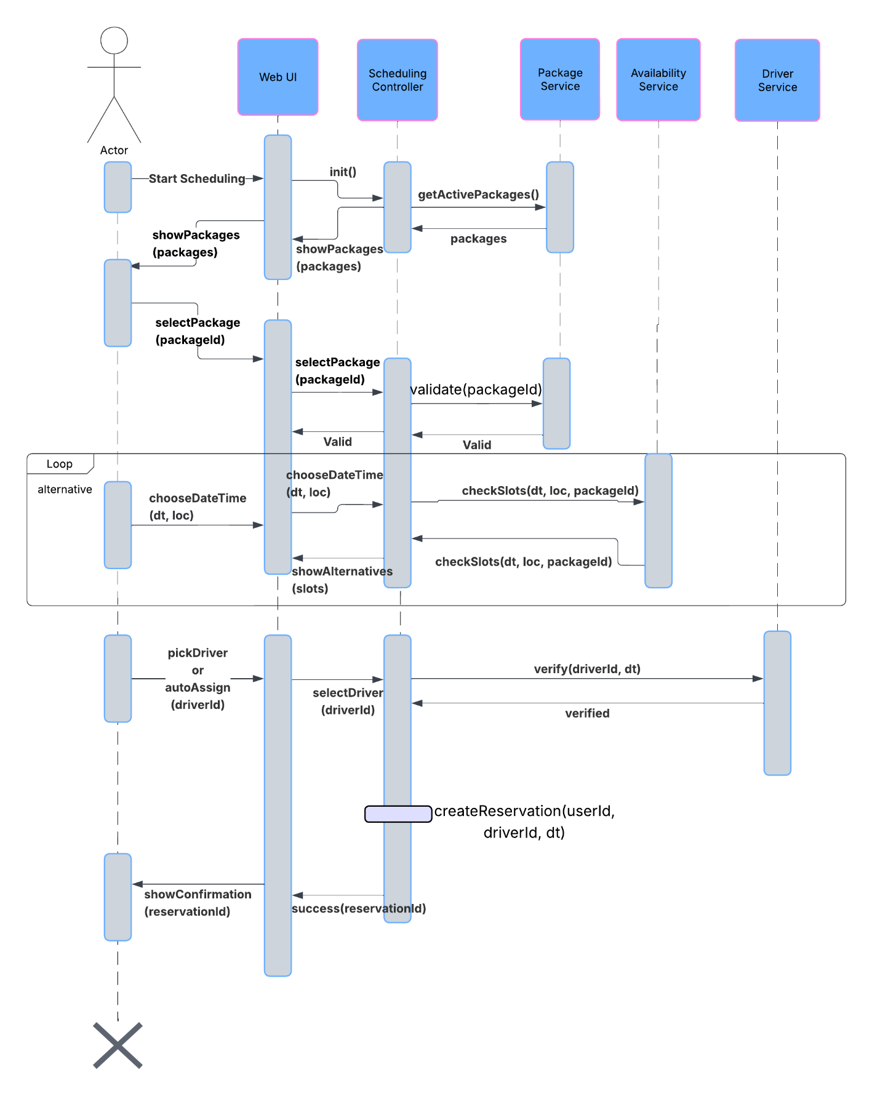

UML Class Diagram
Driverpass UML Class Diagram
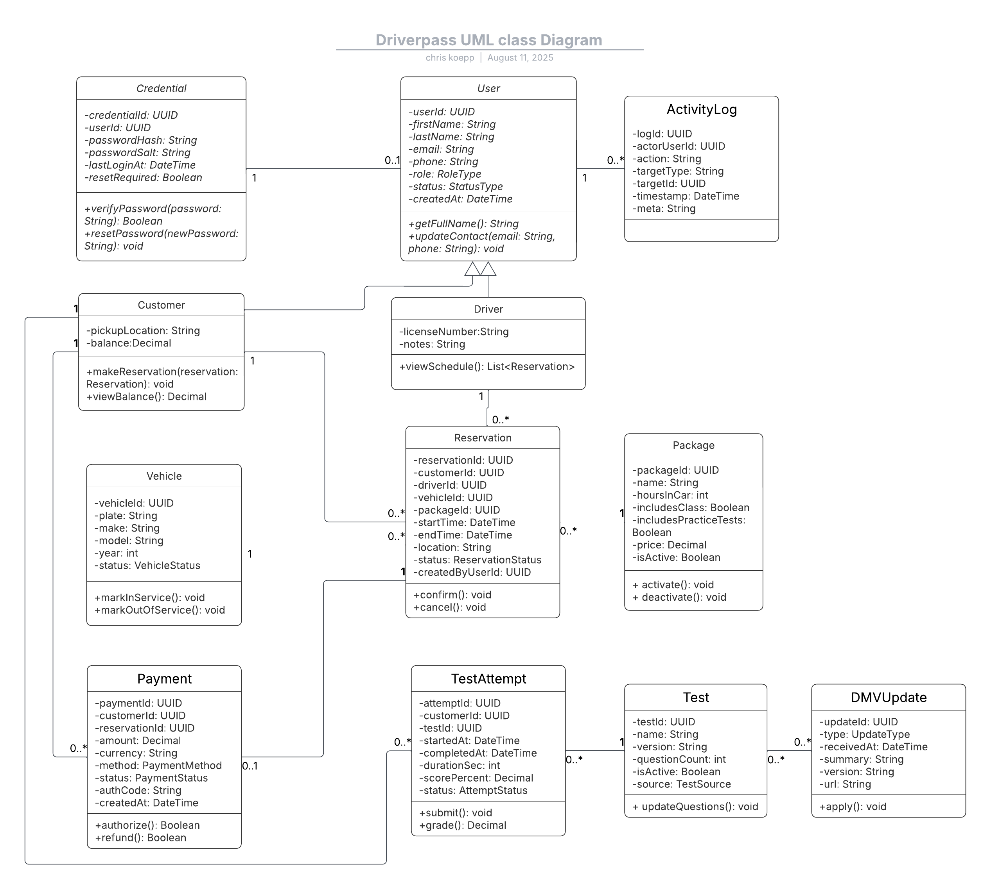

Technical Requirements
- Platform and Hosting
  - Cloud hosted web app for availability anywhere with internet
  - Front end, API, and database all kept separately
  - Managed hosting for uptime, backups, and patches for security
- Hardware
  - Standard cloud compute instances with automatic scaling so we don’t lose performance during peak activity
  - Well managed databases with frequent backups
  - Object storage for the reports and DMV updates
- Software
  - WEB UI built in either HTML or JavaScript that’s also mobile capable
  - Backend API in a prominent code language
  - Relational SQL database built in accordance with the class diagrams
- Features from the design
  - Role based access for control of access to the different aspects of the app
  - Secure booking portal with a hold on the slot while booking to avoid double booking
  - Payment integration with popular payment methods
  - Practice test system with scoring and progress updates
  - DMV update import process for compliance
  - Activity log for important activities
- Security
  - HTTPS/TLS for all traffic
  - Passwords hashed in storage, mandatory
  - No storage of payment (card) information, keep it native to payment system
  - Input validation, rate limiting, and role checks for the api
- Performance
  - Maintain near constant uptime
  - Automate frequent, daily backups
  - Monitor for processing issues with hardware
  - API responses should be under a reasonable ms (maybe 500ms)
  - Caching while app loaded to run faster on user side
- Client devices
  - Works on modern browsers (Chrome, Mozilla, Safari, Edge)
  - Mobil support for both Android and iOS
- Constraints
  - No changes to data while offline
  - Packages need to be able to be enabled or disabled, but only dev can add or remove types.

